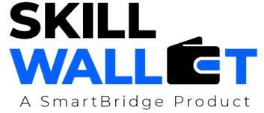

OptiCrop: AI Based Crop Recommendation System

Communication

Communication Plan:
Effective communication is essential for a successful project demonstration. This document outlines the communication strategy used within the team and with stakeholders throughout the project lifecycle, including how updates, issues, and feedback were managed.

S.No | Communication Type | Frequency | Channel / Tool | Participants | Purpose
1 | Team Standup | Daily | WhatsApp / Google Meet | Project Team | Discuss daily tasks and project progress.
2 | Progress Update | Weekly | Google Meet / GitHub | Team Members & Guide | Review completed work and assign new tasks.
3 | Issue / Bug Discussion | As Needed | WhatsApp / GitHub | Developers | Resolve coding errors and technical issues.
4 | Stakeholder Review | Bi-Weekly | Google Meet | Guide & Project Team | Collect feedback and improve the project
5 | Final Demo Rehearsal | Once | College Lab / Google Meet | Entire Team | Practice the final project presentation.
6 | Documentation Review | Weekly | Google Docs | Team Members | Verify and update project documentation.

Communication Challenges & Resolutions:
S.No | Challenge Faced | Resolution / Action Taken
1 | Delay in integrating machine learning modules | Assigned tasks among team members and reviewed code together.
2 | Errors during API and database integration | Debugged the application, corrected configuration settings, and tested the modules.
3 | Managing documentation and code versions | Used GitHub for version control and Google Docs for collaborative documentation.

